4B OS Lab-03 Lab Tasks

**Muhammad Danish | CS182019 | 4B**

# **Q1)**

**Example – 01:**

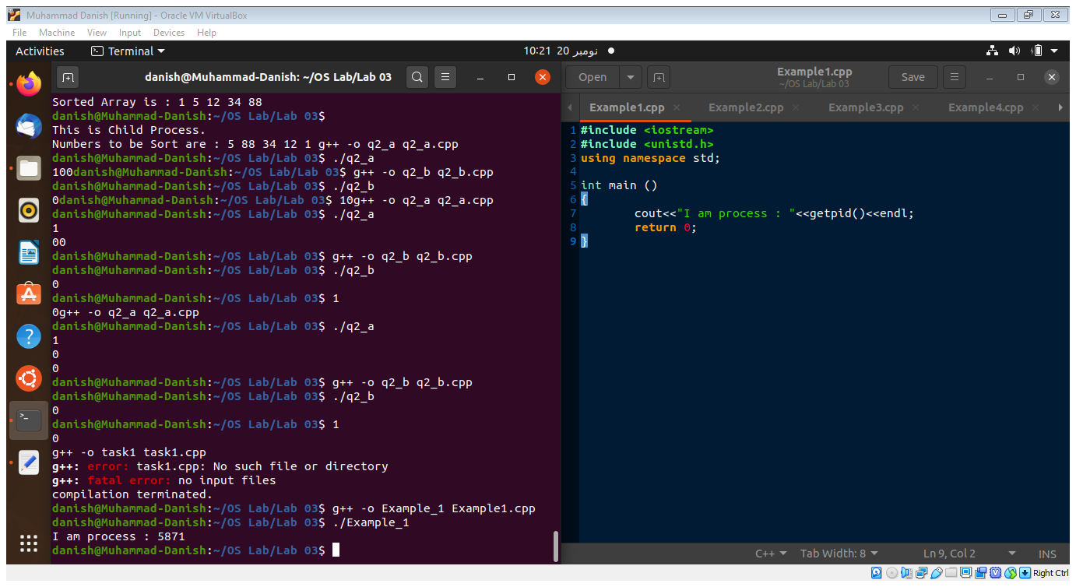



**Example – 02:**

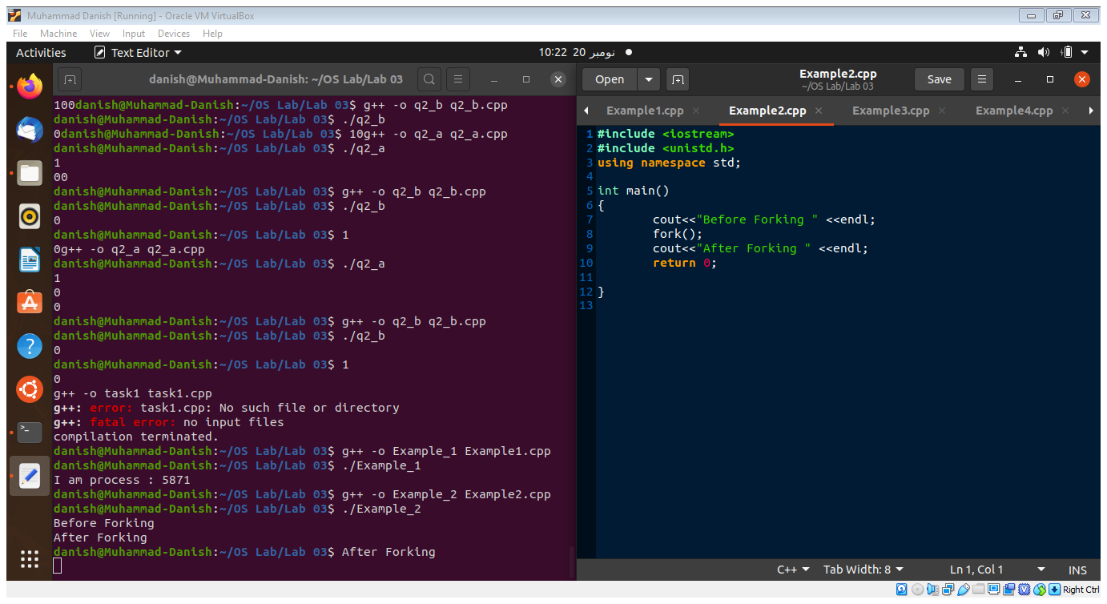



**Example – 03:**

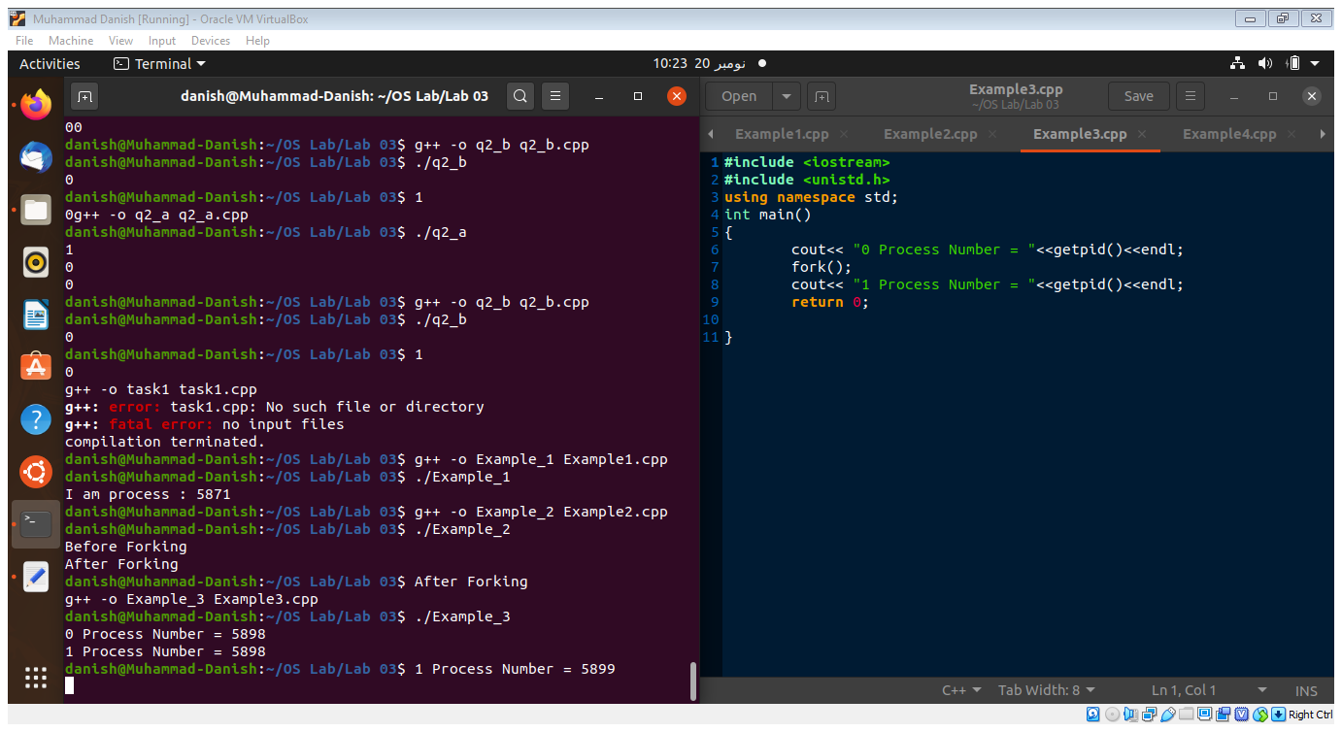



**Example – 04:**

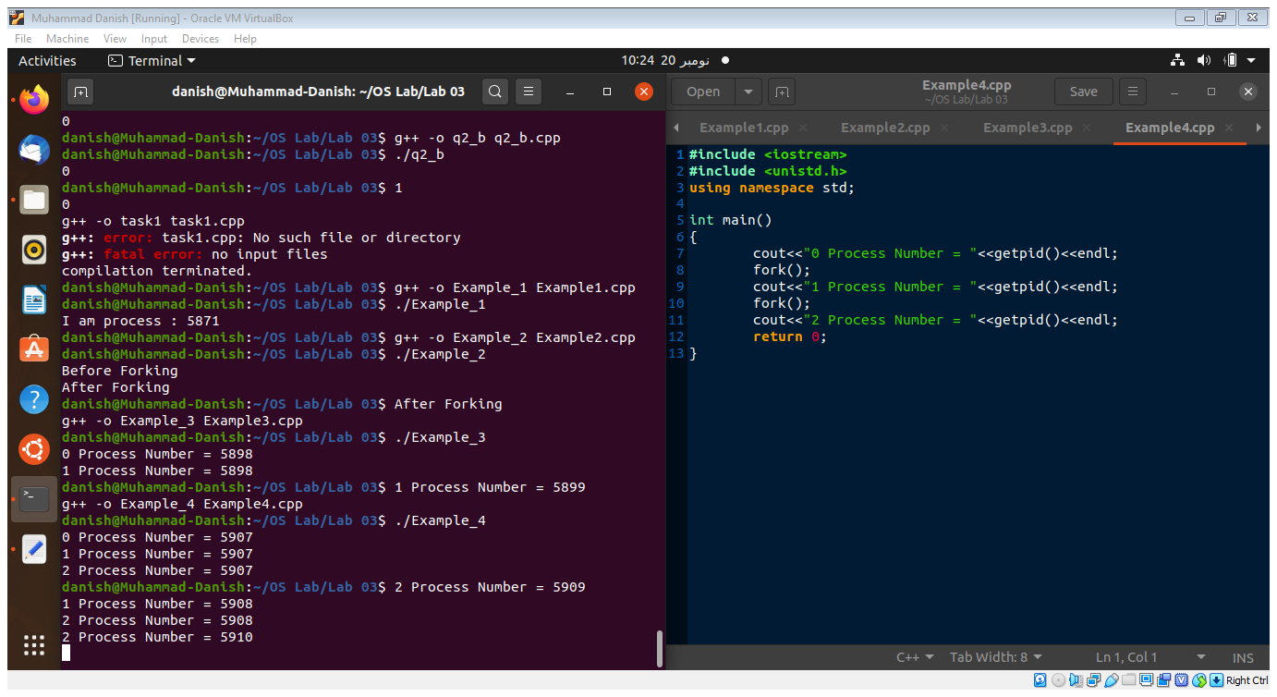



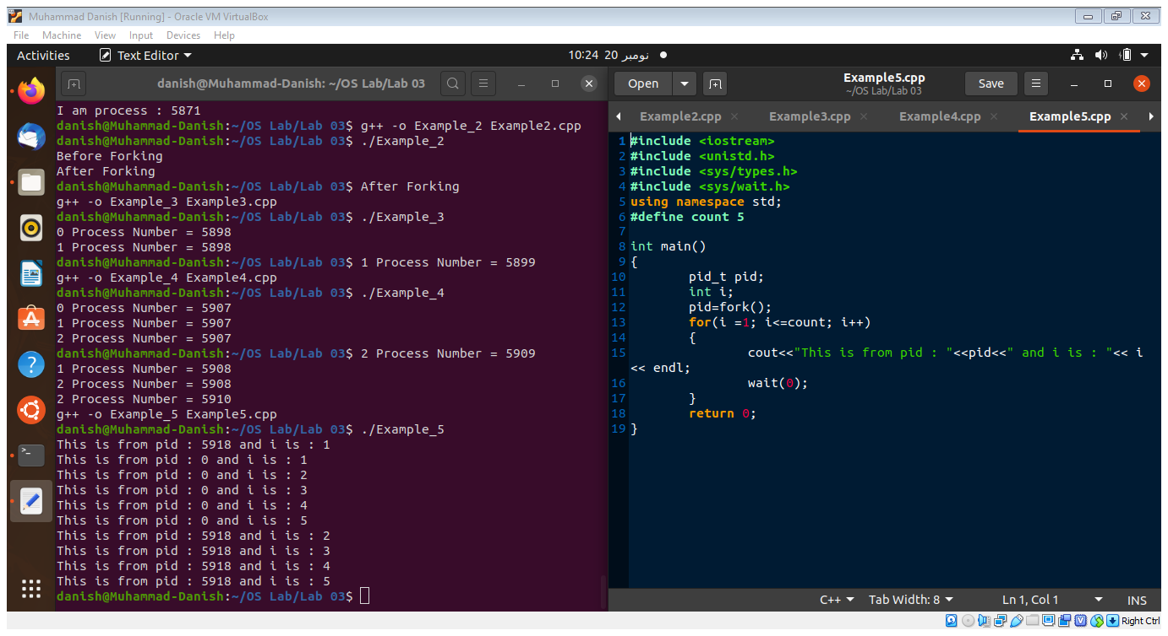**Example – 05:**



**Example – 06:**

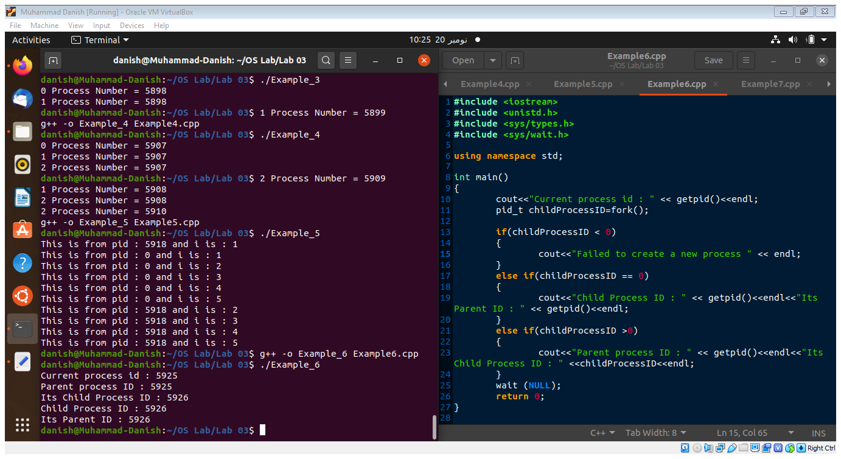



**Example – 07:**

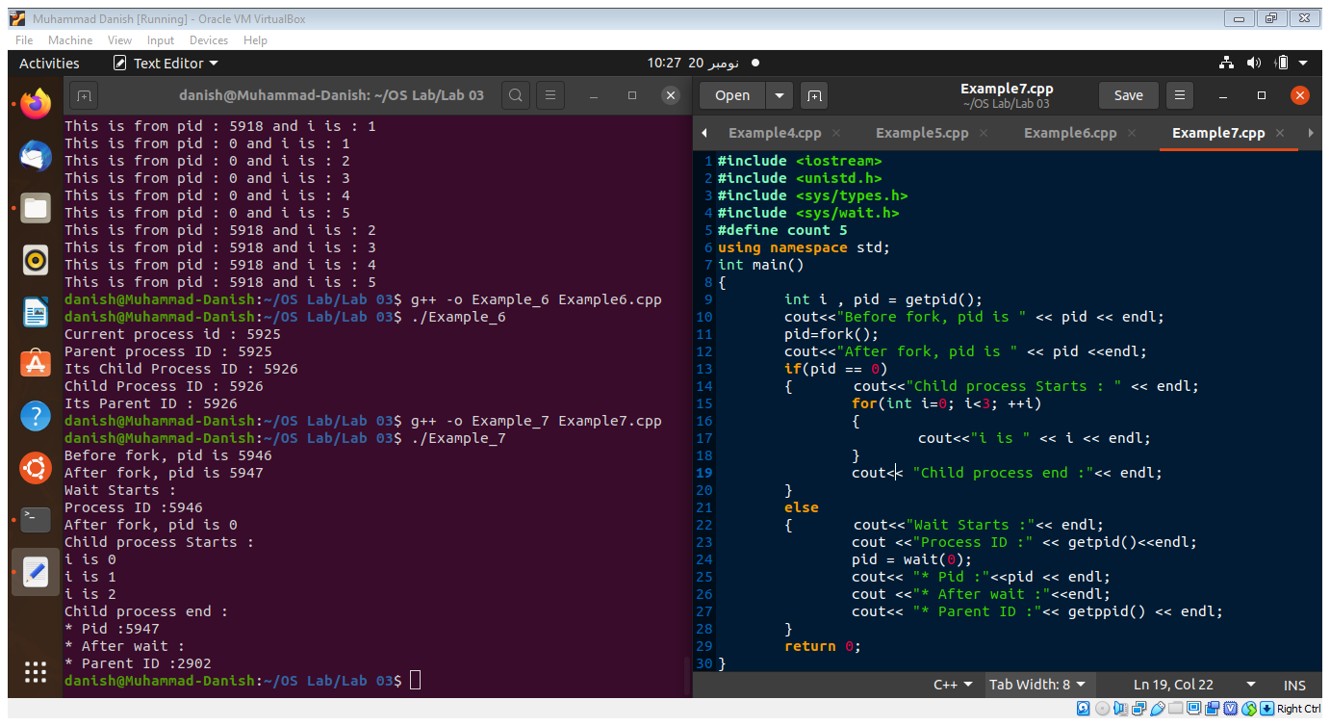



# **Q2)**

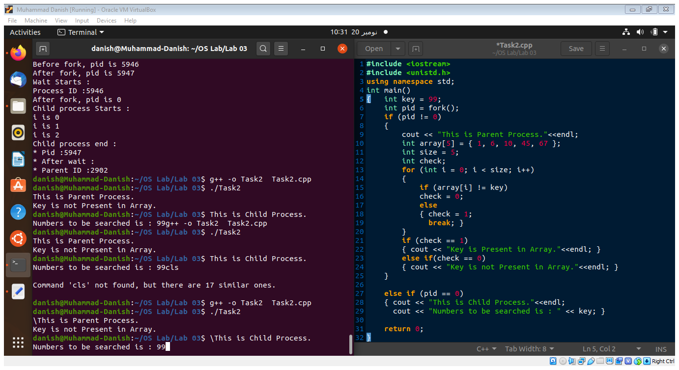



**Muhammad Danish | CS182019 | 4B**